

MINI PROJECT

**(2021-22)**

**“LEARNER EDGE”**

Project Report

**Institute of Engineering & Technology**

**Submitted By -**

###### Anjali singh(191500118)

Gaurav Kumar Dubey(191500292)

Divyam Saxena(191500273)

Faiz Mukarram(191500283)

Aditi Tyagi(191500054)

**Under the Supervision Of Mr. Mandeep Singh Technical Trainer**

**Department of Computer Engineering & Applications**

Department of Computer Engineering and Applications GLA University, 17 km. Stone NH#2, Mathura-Delhi Road, Chaumuha, Mathura – 281406 U.P (India)

## Declaration

I/we hereby declare that the work which is being presented in the Bachelor of technology. Project **“LEARNER EDGE”**, in partial fulfillment of the requirements for the award of the ***Bachelor of Technology*** in Computer Science and Engineering and submitted to the Department of Computer Engineering and Applications of GLA University, Mathura, is an authentic record of my/our own work carried under the supervision of **Mr. Mandeep Singh, Technical Trainer, Dept. of CEA,GLA University.**

**Sign**: *Anjali Singh* **Sign**: *Divyam Saxena*

**Name of Candidate**: Anjali Singh **Name of Candidate**: Divyam Saxena

**University Roll No**.:191500118 **University Roll No.:**191500273

**Sign:** *Faiz Mukarram* **Sign**: *Aditi Tyagi*

**Name of Candidate:** Faiz Mukarram **Name of Candidate**: Aditi tyagi

**University Roll No**.:191500283 **University Roll No**.:191500054

**Sign:** *Gaurav kr Dubey*

**Name of Candidate**: Gaurav kumar Dubey

**University Roll No:** 191500292

Department of Computer Engineering and Applications GLA University, 17 km. Stone NH#2, Mathura-Delhi Road, Chaumuha, Mathura – 281406 U.P (India)

## Certificate

###### This is to certify that the project entitled “Book Finder App”, carried out in Mini Project – I Lab, is a bonafide work by As Aditi Tyagi, Faiz Mukarram, divyam Saxena, Gaurav Kumar Dubey and Anjali Singh and is submitted in partial fulfillment of the requirements for the award of the degree Bachelor of Technology (Computer Science & Engineering).

**Signature of Supervisor:**

**Name of Supervisor:** Mr. Piyush vashishta

**Date:**

**Training Certificates**

* **Faiz Mukarram**
* **Gaurav Kumar Dubey**
* **Anjali Singh**
* **Aditi Tyagi**
* **Divyam Saxena**

Department of Computer Engineering and Applications GLA University, 17 km. Stone NH#2, Mathura-Delhi Road, Chaumuha, Mathura – 281406 U.P (India)

**ACKNOWLEDGEMENT**

Presenting the ascribed project paper report in this very simple and official form, we

would like to place my deep gratitude to GLA University for providing us the instructor Mr Mandeep Singh, our technical trainer and supervisor.

He has been helping us since Day 1 in this project. He provided us with the roadmap, the basic guidelines explaining on how to work on the project. He has been conducting regular meeting to check the progress of the project and providing us with the resources related to the project. Without his help, we wouldn’t have been able to complete this project.

And at last but not the least we would like to thank our dear parents for helping us to

grab this opportunity to get trained and also my colleagues who helped me find

resources during the training.

Thanking You

**Sign**: *AnjaliSingh* **Sign**: *AditiTyagi*

**Name of Candidate**: Anjali Singh **Name of Candidate**: Aditi Tyagi

**University Roll No**.:191500118 **University Roll No**.:191500054

**Sign:** *DivyamSaxena* **Sign**: *Gauravdubey*

**Name of Candidate:** Divyam saxena **Name of Candidate**: Gaurav Kumar dubey

**University Roll No**.:191500273 **University Roll No**.:191500292

**Sign:** *Faizmukarram*

**Name of Candidate**: Faiz Mukarram

**University Roll No:** 191500283

**ABSTRACT**

E-learning fulfils the thirst of knowledge and offers online content that can be delivered for the learner at anywhere, anytime and any age through a wide range of e-learning solution while compared with traditional learning system. It also provides the rapid access to specific knowledge and information. With the rapid growth of voluminous information sources and the time constraint the learning methodology has changed. Learners obtain knowledge through e-Learning systems rather than manually teaching and learning. This system supports the cross browser and fully integrated with different databases. This system focused around the several features namely Content Management, Content Protection, Learning Management, Delivery Management, Evaluation management, Access Control, etc., and mainly focused on integrated platform needed for e-learning and managements.



**CONTENTS**

Cover Page

Declaration……………………………………………………………………….

Certificate

Training Certificate…

Acknowledgement

Abstract

Content

List Of figures

List Of tables

Chapter 1Introduction 1

* + 1.1 Context… 1
  + 1.2 Motivation 1
  + 1.3 Objective 2
  + 1.4 Existing System 2
  + 1.4 Sources 3

Chapter 2 Software Requirement Analysis 4

* + 2.1 Significance of Education 4
  + 2.2 Problem Statement… 5
  + 2.3 Hardware and Software Requirements 6
  + 2.4 Modules and Functionalities 6
  + 2.5 Learner Edge on Web App……………,,,,,, 7

Chapter 3 Software Design… 8

* + 3.1 Use Case Diagram 8
  + 3.2 Data Flow Diagram 11
  + 3.3 Sequence Diagram 12

Chapter 4 Technology Used… 13

* + 4.1 Web Development… 13
  + 4.2 Types of Development 14
  + 4.3 Tools and Languages 15
  + 4.4 Basic Terminology 16

Chapter 5 Implementation and User Interface 19

* + 5.1 Implementation of User InterFace 19
  + 5.2 User Interface 23

Chapter 6 Testing 33

* + 6.1 Installation Testing… 33
  + 6.2 Unit Testing… 34
  + 6.3 User Testing 37
  + 6.4 Performance Testing 38
  + 6.5 Compatibility Testing 39

Chapter 7 Conclusion 40

References *41*

**LIST OF FIGURES**

###### Existing System 2

###### Use Case Diagram 9

###### Data Flow Diagram 11

###### Sequence Diagram 12

###### Android Kit-Kat… 14

###### Flow Chart for User 21

###### Splash Screen 23

###### Register Page 23

###### Login Page 24

###### Forget Password… 24

###### Navigation Drawer 25

###### Dashboard Fragment… 26

###### Profile Page 27

###### Favourite Page 28

###### Sign-out Page 28

###### About App Page 29

###### FAQ Page 29

###### Search Book Page 30

###### Description Page 30

###### Book List 31

###### Book added to Favourite… 31

###### Favourites 32

###### Book removed from Favourite 32

# LIST OF TABLES

###### Version of Android… 14

###### Unit testing of Bookopedia 34

**CHAPTER-1 INTRODUCTION**

**CONTEXT**

This Android Application “**learningegde**” has been submitted in partial fulfilment of the

requirements for the award of the degree of Bachelor of Technology in Computer Science and

Engineering at GLA University, Mathura supervised by Mr.Piyush Vashisht. This project has

been completed approximately three months and has been executed in modules, meetings have

been organised to check the progress of the work and for instructions and guidelines.

### MOTIVATION

In the recent years, we have realized the importance of virtual learning and how important it is

for us to have our resources online. Virtual learning provides students with a different opporunity to learn

regardless of where they are and when they are available.In Virtual Learning Environment,students are

able to participate in self-faced and interactive learning that is otherwise impossible.

In the century we are living the world is progressing at a really great pace, a lot number of technologies come up every single day. To keep up with the technology is also important to survive in this world of digitalization and learning. Along with this we need to have a place to keep the resources for areas of our interest so we thought of developing a Website which could provide us with virtual Learning as well as a platform where we could keep the proper Content we like marked.

Moreover this kind of Website can be used in areas/schools . This would be an excellent effort to provide education without any boundaries to all.

### OBJECTIVE

The main objective of this Website is to create a E-learning named “**LearningEdge**” .

Learner Edge is a web Application for Online learning Platform.This is the best Application for the Students to find everthing related to studies under a same page.Students can easily access its module on clicking on widgets which is self-explanatory.

This application will help the students to see the detailed syllabus of their subjects.and According to the syllabus, students need not to run to library for the study material.This application will help students to get detailsof name of the books associated to all the subjects , and also provide the videos of the lecture in both English and Hindi Language so that it provides the choice to the student,however he/she wants to learn it.

Apart from the curriculum subjects ,our application seems more informative for the students who wants to prepare for competitive exams,we provide a General Knowledge module which will help students to get an idea of the competitive questions.It will also show the teachers name associated to the Students feel free to know about the respective teachers and clear their doubts.

### EXISTING SYSTEM

In the present scenario, It helps the studies to learn a small and necessary amount of useful information about a particular Subjects.It provides information to the professionals when they need it saves everone’s time.As this idea as already implemented here are the some snap how our application will look.

As soon as the user enters the application ,there will be landing page containing the name of the web app and then there will be login/sign up page. Initially there will be search bar as shown in the image below .Then on the basis of certain keywords the website will fetch the results and the content will be displayed as shown in the second screenshot.

**Figure-1: Existing System**

* 1. **SOURCES**

The source of our project (including all the project work, documentations and presentations) will is available at the following link

https://github.com/Divyam192001/Learner-Edge-Mini-project

**CHAPTER -2**

**SOFTWARE REQUIREMENT ANALYSIS**

### SIGNIFICANCE OF EDUCATION

Education is the one of the main reason that allow people to grow and to develop as perfect individual in

society.It reaches people important life values, and it opens their mind to a lot of interesting aspects of life and

not only classrooms are ideal places for healthy discussio on all kinds of subjects.At the same time ,education

encourages people to develop their social skills,problem-solving skills,and creative skills. In order to become a

genuine person I one has to pick the right education system.

It is the key to success in the future , and to have many opporunities in our life.Educatiuon has many advantages

for people .For instance , it illuminate a person’s mind and thinking .It helps students to plan for work,or pursue

higher education by graduating from University.Having education in an area helps people think,feel, and behave

in a way that contributes to their success,and improves not only their personal satisfaction but also their

community.In addition, Education develops human personality. Thoughts,and social skills.it also prepares people

for life experiences.It makes people have a special status in their own society and everywhere they live.I believe

that everyone is entitled to have education”from cradle to grave”.There are various benefits of having

education,such as having a good career, having a good status in society, and having self-confidence.

Education today must make a human with social responsibility.The real purpose of education is to make every

human to be a better persons with love for oneself,others and for the nation.We must understand that “A Child is

not a vase to be filled but a fire to be lit”.Education in the modern days should aim at building a new society of

love, justice,equality and peace.

Its is the lamp which should kindle the fire in preparation for the adventures of life and to face any kind of

situation with confidence.

To state that education is vital will mean putting it mildly.Instruction is a weapon to improve one’s life.It

Is a long-lasting procedure that closes only with death .Education undoubtedly decides the nature of a person’s

life.

### PROBLEM STATEMENT

The website “LearningEdge” is a website which will allow users to connect with the world

of learning with the help of different types of subject on the ease of fingertips. It will allow users to

decide which subject are more useful to them by reading a short note for that particular Subject and it will also

allow user to choose the instructor for his/her as per choice so that they can get the most out of these and they

will fully satisfied for the time the are giving . Our contact info is also mentioned at the home page where

user can always contact us every time user is having a difficulty in using the website.

This website is complete a Learning guide with all the qualities, facilities a person desires or

required with the proper user interface as well.

### HARDWARE AND SOFTWARE REQUIREMENTS

**Hardware Requirement**

* + - Processor :intel i3
    - Operating System :Window 10
    - RAM : 4 GB
    - Hard disk : 1TB
    - Hardware Devices : Computer System

**Software Requirement**

* + - Software used: Visual Studio Code
    - Language used : HTML , CSS , JavaScript
    - Database: MySQL
    - User Interface Design : Window UI
    - Web Browser : Google Chrome
  1. **MODULES AND FUNCTIONALITIES**
* **Home Page**: The first screen with which the user interacts will be this screen

containing a sample video with a navigation bar

* **Login Page**: This page is for those users who have already registered themselves on the app and have a username and a password. There is also a way on this page for the new users to register themselves which will take them to the registration page.
* **Registration Page:** This is page is solely designed for the new users of the app who are willing to register themselves. This page takes input of the various details of the user and stores it in the database, later helping the user to login into the account with credentials they have provided.
* **Navigation Drawer**: This is the most important part of the application that provides interactivity within the app as it connects the various activities together like it is a side bar on which the profile, the dashboard, the favourites section, the FAQ section ,the About page of the page are linked and on clicking on each you can visit the pages.
* **Dashboard Page:** This is the page displayed for every user after entering the app successfully. It contains the search bar where the user can search the book according to the wish as well as some of the books are suggested with the genres recently searched or the most popular one.
* **Book Description Page**: After searching the book there are a number of books that appear, when the user select the book the page will be displayed that will contain all the details of the book i.e. the book poster author name, price and a short summary of the book and the link to buy the e-book.
* **Favourites Page:** Initially the page is empty, but when the users search for a book and like it then one can add it to the favourites section. This place is a user’s personal space to store any book he likes or want to mark.
* **Profile**: This page will contain all the user details that the user entered while creating the account on the app. The user can update and make changes to all this information as desired.
* **FAQ Pages:** This page contains some of the questions that might arise in the mind of the users while using the app and to answer those, these answers are pre-written.
* **Logout page**: Then is this last panel for the users to sign out from the account. As soon as the users sign out they are brought back to the login page.

### Learner Edge on web App

Learning edge is actually a learning platform.A learning platform (or e-Learning platform) is **an online portal that provides learners and administrators with tools and resources to help enhance the delivery and management of training initiatives**.

Learners Edge is a **leading direct-to-teacher provider of online professional development, continuing education and master's degree programs**

*This web app will give students a* new ways to show their love for learning review them online, keep track of what they read, share photos of their bookshelf with friends, and, of course, discover new books to read.

CHAPTER- 3

**SOFTWARE DESIGN**

### USE-CASE DIAGRAM:

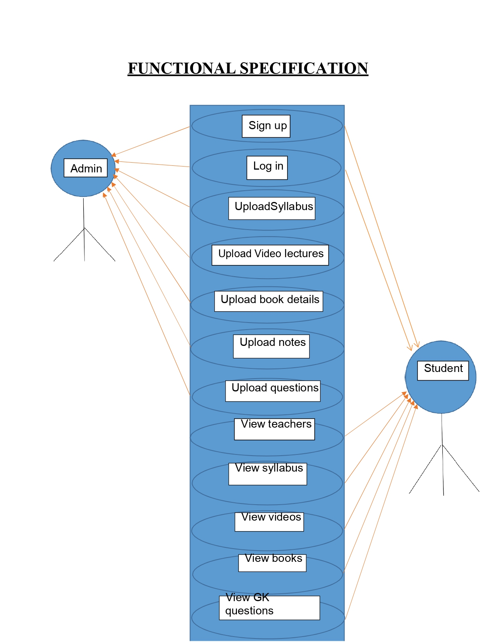

**Figure-2: Use–Case Diagram**

So the above diagram represents the point of view of the new user, the registered user, and the Admin and the arrows to each module show the interactivity of the person.

The New user will first create a new account and will interact with the “sign-up module” and fill up all the details that will be stored in the database ,then will login into the account. The next user will land into the dashboard where there will be options for “view videos”,”view syllabus”,”view teachers”,”view books” and “view GK questions” where the user can view video lectures ,teachers for specific courses,enter the book he desires to read and syllabus.

For the registered user, the user will be having the credentials to login and will interact with the “login module” and then the user will enter into the dashboard where there will be all the requirements.

For the Admin he can connect with each and every module mentioned in the use case diagram. Apart from the modules mentioned in use case diagram there are modules like profile, sign out, FAQ and about us section that every registered user can access.

* 1. **DATA FOW DIAGRAM**

The book list details contain the author name, the book poster, the book genre, and a short review about the book, the price of the book and the link to buy the book. The plus point of this app is it is connected to the Google book API so as soon as a new book is published; it is automatically to the app also.

As soon as the user encounters with the login module, we check the credentials of the user if the credentials are correct as per the database we proceed to the dashboard else if wrong we encounter the forget password module and then mail is sent to the registered mail id. From the dashboard module, we can interact with the favourites section, the profile module, the FAQ Section, The sign out section. On searching the book, from the dash board module, we encounter the check book list activity, checking the book details activity and the published date activity.

The DFD for the learning edge is shown below:

### SEQUENCE DIAGRAM

## CHAPTER-4

## TECHNOLOGY USED

# 4.1 WEB DEVELOPMENT

Web development refers to the building, creating, and maintaining of websites. It

includes aspects such as web design, web publishing, web programming, and

database management. It is the creation of an application that works over the internet

i.e. websites. The word Web Development is made up of two words, that is:

* **Web:**It refers to websites, web pages or anything that works over the internet.
* **Development:**Building the application from scratch.

Web development is divided into two ways:

* Frontend development
* Backend development

•**Frontend development** : The part of a website that the user interacts directly

is termed as front end. It is also referred to as the ‘client side’ of the application.

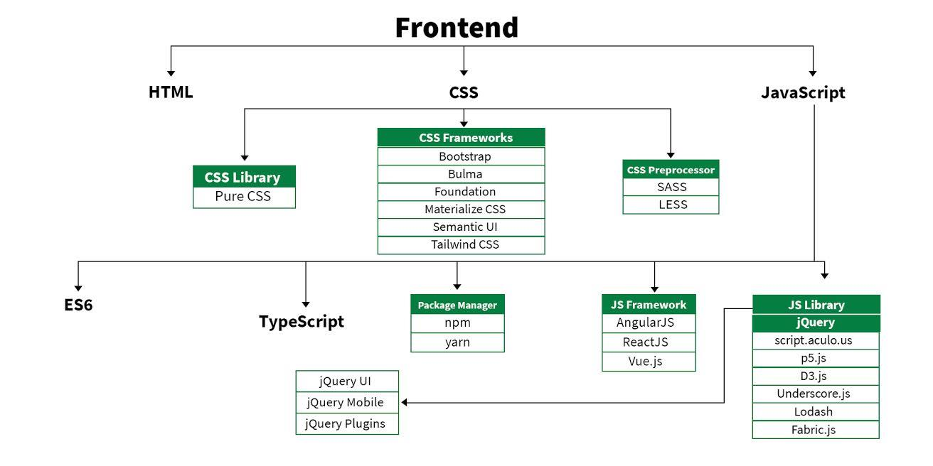

Backend development : Backend is the server side of a website. It is the part of the website that users

cannot see and interact. It is the portion of software that does not come in direct contact with the users.

It is used to store and arrange data.

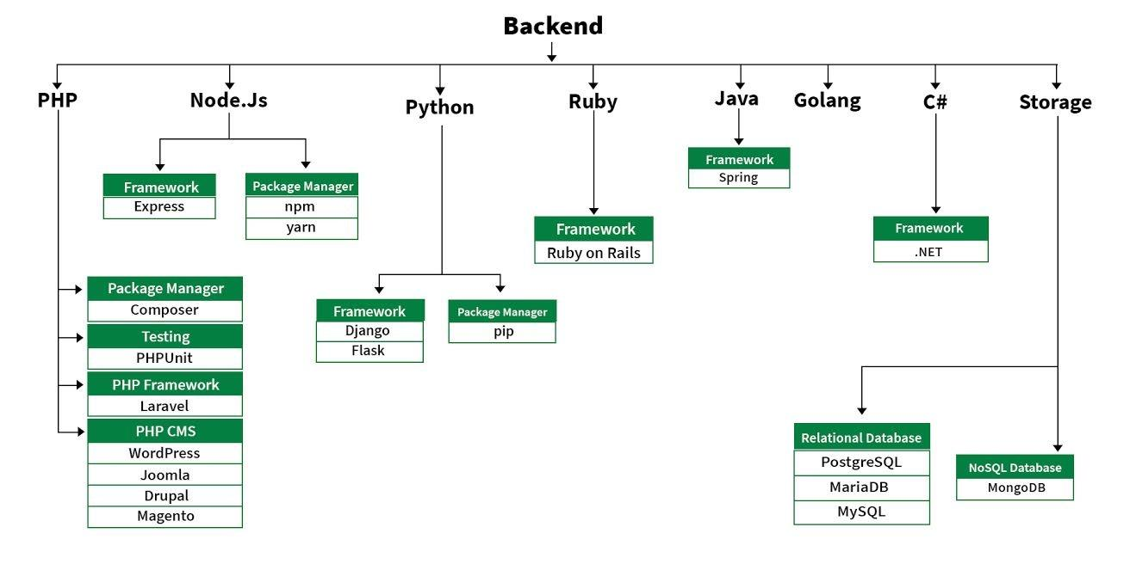

### 4.2 TOOLS AND LANGUAGES

* **VSCode** **:**Visual Studio Code is a source-code editor made

by Microsoft for Windows, Linux and macOS. Features include support

for debugging, syntax highlighting, intelligent code completion, snippets, code

refactoring, and embedded Git. Users can change the theme, keyboard shortcuts,

preferences, and install extensions that add additional functionality.

Languages used in building a website are classified as per the Front End and Back End. For

designing the Front End of the website we have used CSS and for designing the Back End we

have used MongoDB.

* **HTML** :The Hyper Text Markup Language, or HTML is the standard markup

language for documents designed to be displayed in a web browser. It can be

assisted by technologies such as Cascading Style Sheets (CSS) and scripting

languages such as JavaScript. Web browsers receive HTML documents from a web

server or from local storage and render the documents into multimedia web pages.

HTML describes the structure of a web page semantically and originally included

cues for the appearance of the document. HTML elements are the building blocks of

HTML pages. With HTML constructs, images and other objects such as interactive

forms may be embedded into the rendered page. HTML provides a means to create

structured documents by denoting structural semantics for text

such as headings, paragraphs, lists, links, quotes and other items. HTML elements

are delineated by tags, written using angle brackets. HTML can embed programs

written in a scripting language such as JavaScript, which affects the behavior and

content of web pages.

* **BOOTSTRAP** :Bootstrap is a free and open-source tool collection for

creating responsive websites and web applications. It is the most popular HTML,

CSS, and JavaScript framework for developing responsive, mobile-first websites. It

solves many problems which we had once, one of which is the cross-browser

compatibility issue. Nowadays, the websites are perfect for all the browsers (IE,

Firefox, and Chrome) and for all sizes of screens (Desktop, Tablets, Phablets, and

Phones). All thanks to Bootstrap developers - Mark Otto and Jacob Thornton of

Twitter, though it was later declared to be an open-source project

* **CSS:**CSS (Cascading Style Sheets) is a stylesheet language used to design the

webpage to make it attractive. The reason of using CSS is to simplify the process of

making web pages presentable. CSS allows you to apply styles to web pages. More

importantly, CSS enables you to do this independent of the HTML that makes up

each web page. There are three types of CSS which are given below:

* **Inline CSS**
* **Internal or Embedded CSS**
* **External CSS**
* **JavaScript :**JavaScript is the world most popular lightweight, interpreted

compiled programming language. It is also known as scripting language for web

pages. It is wellknown for the development of web pages, many non-browser

environments also use it. JavaScript can be used for Client-side developments as

well as Server-side developments.

JavaScript can be added to your HTML file in two ways

* **InternalJS :**We can add JavaScript directly to our HTML file by writing the

code inside the <script> tag. The <script> tag can either be placed inside the <head>

or the <body> tag .according to the requirement.

* **ExternalJS:**We can write JavaScript code in other file having an extension .js

and then link this file inside the <head> tag of the HTML file in which we want to

add this code.

* **MongoDB:**MongoDB, the most popular NoSQL database, is an open-source

documentoriented database. The term ‘NoSQL’ means ‘non-relational’. It

means that MongoDB isn’t based on the table-like relational database structure but

provides an altogether different mechanism for storage and retrieval of data. This

format of storage is called BSON ( similar to JSON format).

### BASIC TERMINOLOGY

* + - **Layout:** Layout is the parent of view. It arranges all the views in a proper manner on the screen.

.

* **CSS File :**CSS (Cascading Style Sheets) are files that describe how HTML elements are displayed on the screen, paper, etc. With HTML, you can have either embedded styles or styles can be defined in an external stylesheet. For embedding the styles, the <style></style> tags are used. The external stylesheets are stored in files with the .css extension. With the external CSS, you can include it on multiple HTML pages to update the style of those pages. Even a single CSS file can be used to style a complete website.
* **HTML File :**HTML is a HyperText Markup Language file format used as the basis of a web page. HTML is a file extension used interchangeably with HTM. HTML is consists of tags surrounded by angle brackets. The HTML tags can be used to define headings, paragraphs, lists, links, quotes, and interactive forms. It can also be used to embed JavaScript and CSS (cascading style sheets). JavaScript File:Within a browser, JavaScript doesn't do anything by itself. You run JavaScript from inside your HTML webpages. To call JavaScript code from within HTML, you need the <script> element. There are two ways to use script, depending on whether you're linking to an external script or embedding a script right in your webpage.
  + - **Activity**: An activity can be referred as your device’s screen which you see. User can place UI elements in any order in the created window of user’s choice.
    - **View**: A view is an UI which occupies rectangular area on the screen to draw and handle user events.
    - **API:** Short for Application Programming Interface. APIs are functions that developers can call on to access specific features by calling upon programs, code, and services that others have written. For example, if a developer wants to draw a button on the screen, she can insert a small bit of code that says “draw this kind of button, with this color and size and style, at this location” instead of dozens of lines of code that tells the graphics processor, in detail, exactly how to draw a button. If the application wants your location, it can use the location API to “get the device’s location” and let Google’s code handle the rest, instead of requiring the developer to build an entire location service from scratch just for her own app. There are thousands of APIs in Android, covering everything from drawing interface elements, to the cameras, to location access, to accessing storage, to 3D graphics (see: OpenGL ES) and much more.
    - **Intent:** Intents are an essential part of the Android ecosystem. They are used to express an action to be performed. Intents allow you to interact with components from the same applications as well as with components contributed by other applications. It can be classified into implicit and explicit intents.
    - **Implicit intent:** It does not name a specific component, but instead declare a general action to perform, which allows a component from another app to handle it.
    - **Explicit Intent:** It specifies the component to start by name. You’ll typically use an explicit intent to start a component in your own app, because you know the class name of the activity or service you want to start.
    - **Action Bar**:The action bar is an important design element, usually at the top of each screen in an app that provides a consistent familiar look between Android apps. It is used to provide better user interaction and experience by supporting easy navigation through tabs and drop-down lists.
    - **Navigation bar**: Android Navigation Drawer is a sliding left menu that is used to display the important links in the application. Navigation drawer makes it easy to navigate to and fro between those links. It’s not visible by default and it needs to opened either by sliding from left or clicking its icon in the Action Bar.
    - **Fragment**: Fragment represents a behavior or a portion of user interface in a Fragment Activity. You can combine multiple fragments in a single activity to build a multi-pane UI and reuse a fragment in multiple activities.
    - **Firebase** is a Backend-as-a-Service (Baas). It provides developers with a variety of tools and services to help them develop quality apps, grow their user base, and earn profit. It is built on Google's infrastructure. Firebase is categorized as a NoSQL database program,

which stores data in JSON-like documents. Firebase has three core services: a real-time database, user authentication and hosting. With the Firebase iOS SDK, you can use these services to create apps without writing any server code.

**JSON :** stands for JavaScript Object Notation. It is an independent data exchange format and is the best alternative for XML. JSON is used for data interchange (posting and retrieving) from the server. Hence knowing the syntax and it’s usability is important. JSON is the best alternative for XML and its more readable by human

**CHAPTER -5 IMPLEMENTATION AND USER INTERFACE**

Creating a website concept design with screen sketches and functional flow

diagrams is the best way to communicate your vision to the website developer.

Making the concept clear to the developer is probably the most important factor in

successful web development. Yet it is one of the most common problems or

obstacles in web development outsourcing project.

No matter what the marketing and profit goals are or if you are outsourcing an app

for your personal use, you need to fully design and document the website concept if

you expect a programmer to make your vision a reality. Developers are not mind

readers and even descriptions given during conversations can be very fleeting

orinterpreted differently. Fully documenting your concept, therefore, leaves little to

chance. The two most important things to do are:

1. Make a comprehensive description of how the wesite works and what it does

(functionality)

B) Create a comprehensive description of what the user sees and does (look and feel).

**CHAPTER-5**

**IMPLEMENTAION AND USER INTERFACE**

**5.1 Implementation of the Learner Edge:**

Implementation of the website Learning Edge is taken place in various phases.

Firstly we build the login interface then Navigation drawer i.e. make fragment for

each of the list item using the navigation view and the make various layout for the

supporting features and connect the website with the database for fetching the login

credential of the user. And finally we parse the Jason object to get the data in the

required format and then display the result.

* + 1. **Step to be followed to develop the app:**

1. Firstly we create the home page for the new user to signup.

2.After that we create login phase which comprises of various phases that are

mentioned below:

• Login Page: allows user to login into the website if the user is existing one

• Register Page: If the user is new to our website then firstly he/she have to register

themselves on the app.

• Forgot Password: allows user to reset the password if it forget the previous

password.

3. Now, we are going to create Navigation drawer for that purpose we have used following

functionality:

• Fragments(SupportFramentManager)

• Menu – items

• Drawer header

• Hamburger icon

• ActionBar Drawable Toggle (help to create navigation Bar)

4. Creating fragment for each of the menu item. Our Menu items are:

• Dashboard

• Profile

• About us

• FAQ

• Favourites

• Sign-Out

5. Now we have created various activities like courses list, Yoga Description and many more.

6. After that we parse the JASON object that we have received as a response for our query to get the data in the standard form.

7. Now we add data (that we have received from Google API) to the Yoga description activity

8. In the description Activity there are various functionality. Some of them are mentioned below.

STEPS FOLLOWED BY THE USER :

1. Firstly, we have build the home page for the website.

2. Then, we have the Login activity which consists of following steps

• Register : for new User

• Login: For existing as well as new user .

3. We authenticate and store the user information from the Firebase authentication.

4.After that, user can scroll through the Gallery in which various type of courses are present.

1. After that user can see all the instructors for the classes.

6. Now you can enjoy and learn more yoga asans for physical as well as mental health..



Figure-19: FAQ’s (b)

**CHAPTER - 6 TESTING**

Once source code has been generated, software must be tested to uncover as many errors as possible before delivery. It is very important to work the system successfully and achieve high quality of software. Testing include designing a series of test cases that have a high likelihood of finding errors by applying software-testing techniques.

System testing makes logical assumptions that if all the parts of the system are correct, the goal will be successfully achieved. The system should be checked logically. Validations and cross checks should be there. Avoid duplications of record that cause redundancy of data.

In other Words, Testing is the process of evaluating a system or its component(s) with the intent to find whether it satisfies the specified requirements or not. It is executing a system in order to identify any gaps, errors, or missing requirements in contrary to the actual requirements.

The Android framework includes an integrated testing framework that helps you test all aspects of your application and the SDK tools include tools for setting up and running test applications. Whether you are working in Eclipse with ADT or working from the command line, the SDK tools help you set up and run your tests within an emulator or the device you are targeting.

There are different types of testing some of them are listed below:

* 1. **Unit Testing**

It focuses on smallest unit of software design. In this we test an individual unit or groups of inter related units. It is often done by programmer by using sample input and observing its corresponding outputs. In this testing technique we are primarily focuses on

* + - Loop methods and function is working fine or not.
    - Misunderstood or incorrect Arithmetic precedence
    - Incorrect Initialization

Unit Testing of the app:

|  |  |  |  |
| --- | --- | --- | --- |
| **Test cases** | **Description** | **Expected Outcome** | **Result** |
| 1 | Start Page – Launch Screen | Should display splash screen with animated text | Pass |
| 2 | Register Screen | Should display register activity where you need to fill the required details | Pass |

|  |  |  |  |
| --- | --- | --- | --- |
| 3 | Login Screen | Should display login screen And ask for your credentials. | Pass |
| 5 | FAQ | Should display the Frequently asked question | Pass |
| 6 | Profile | Should display the information that  you have entered | Pass |

|  |  |  |  |
| --- | --- | --- | --- |
| 14 | Logout | Sign out you from the app | Pass |

Table 1: Unit Testing of Bookopedia

* 1. **User Testing**

User testing is the process through which the interface and functions of a website, app, product, or service are tested by real users who perform specific tasks in realistic conditions. The purpose of this process is to evaluate the usability of that website or app and to decide whether the product is ready to be launched for real users.

This website was tested by our team mates and friends who are using different Laptops also tested on

different emulator to check its performance and it seems to be working fine and users of this website are

satisfied with the facilities and performance of the website and like the way how the website is worked.

* 1. **Performance Testing**

In this type of testing we have checked the performances of our application under some peculiar conditions are checked. Those conditions include:

* + - Low memory in the device.
    - The battery in extremely at a low level.
    - Poor/Bad network reception.

Performance is basically tested from 2 ends, application end, and the application server end. Our app is also performing well in this phase of testing as well. And we are getting positive feedback from user of our app.

* 1. **Compability Testing**

This application was tested and used on different devices. The website worked fine and is stable.

The website worked fine in portrait mode and there isn't any problem with compatibility.

On all types of testing (that we have performed above) our performing well on our website i.e.

Learning Edge.

**CHAPTER -7 CONCLUSION**

Proposed a Learning website that will allow users to search for courses by name,

This application takes in a user input and searches the Subject tpes with the

user input and gets a list of published content based on the users search query.

Search result screen will contain a list of courses with following details: To get the

information of the particular book user can click upon the Subject from the list and

then will be taken to the new tab where description and other information related to

the Subject will be available.

# 